
SUPERIOR UNIVERISTY
NAME: HARIS AHMED FAYYAZ
CLASS: BS-AI (3B)
ROLL NO: SU92-BSAIM-F25-376
SUBJECT: AI LAB
SUBJECT TEACHER: SIR RASIKH

LAB 5
Adversarial Search: Minimax & Alpha-Beta Pruning
TASK 1: Trace the supplied tree by hand using Minimax.
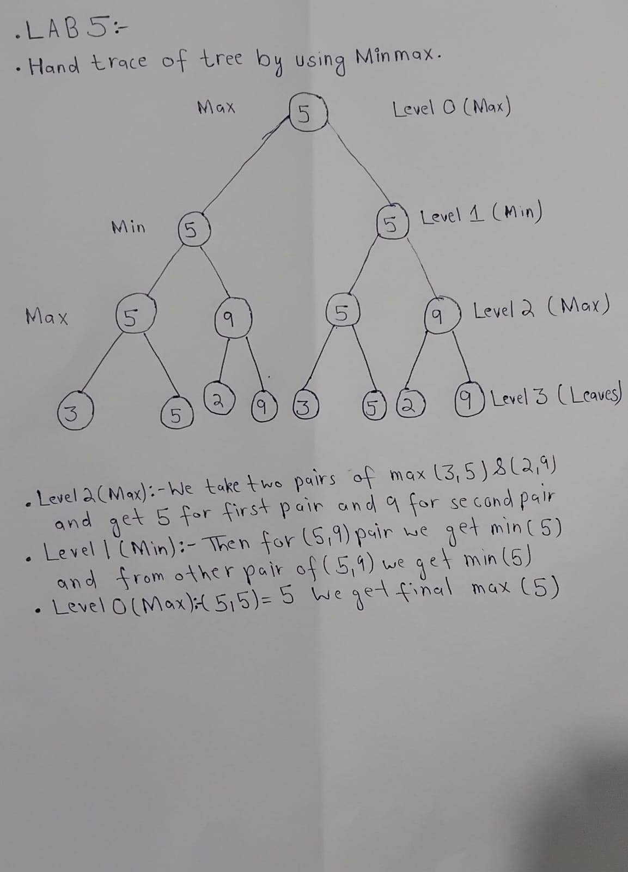

TASK 2: Add a leaf-evaluation counter to both algorithms.
I made a variable count and added 1 to it every time the code reaches a leaf node. This is both done in minimax and Alpha-beta.
TASK 3: Reorder the branches and compare.
CODE AND OUTPUT:
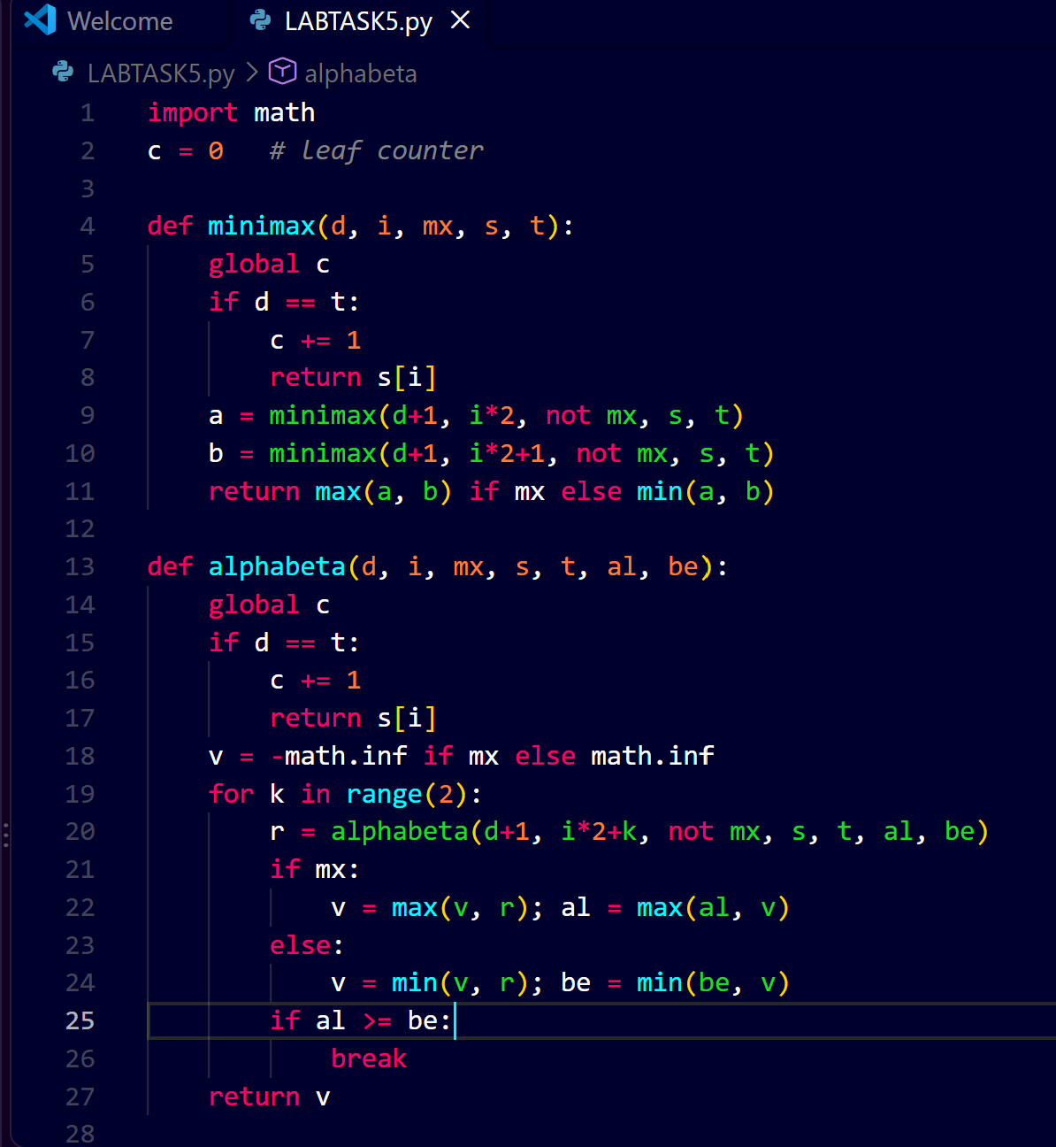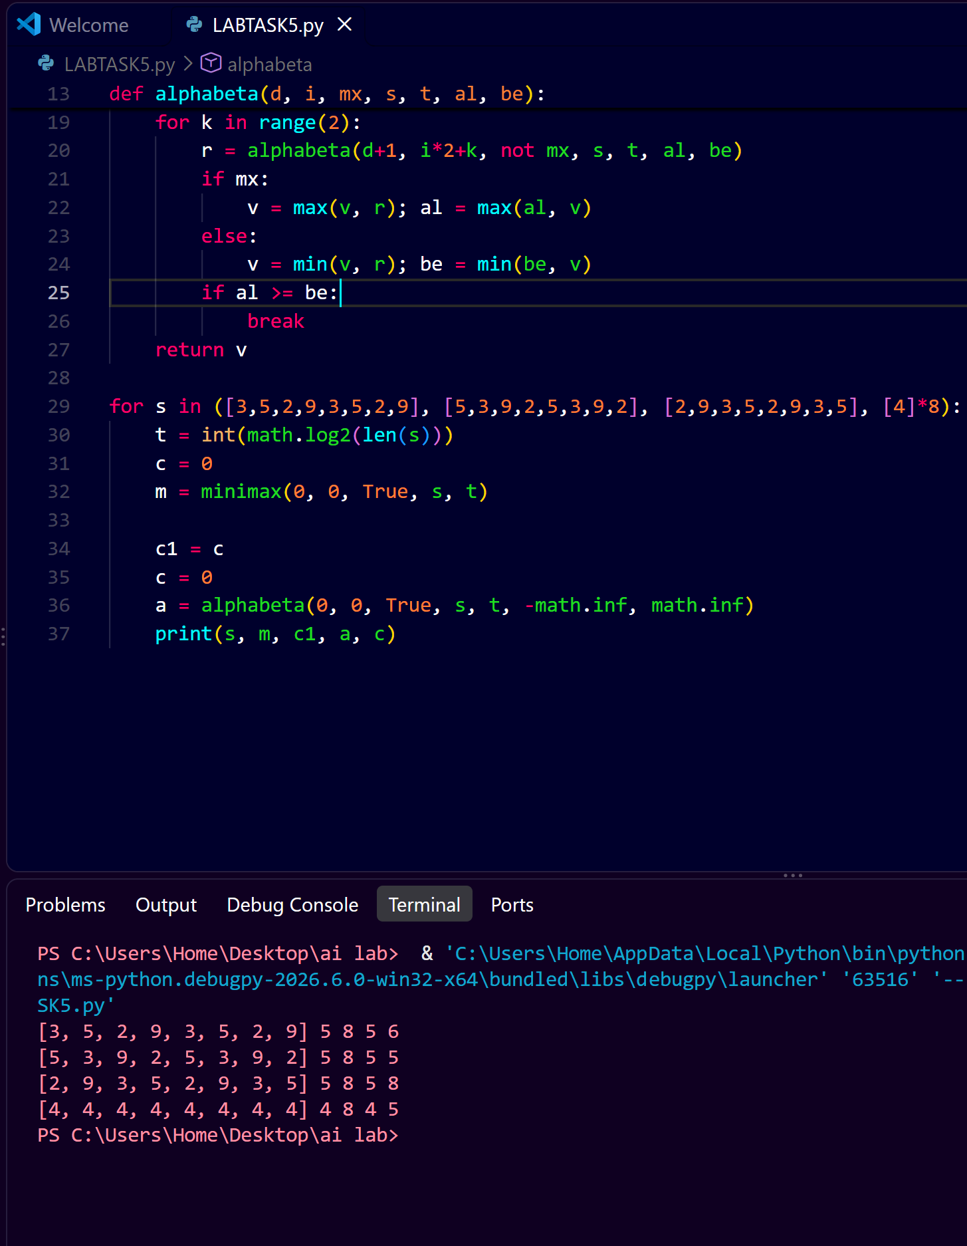
COMPARISON:
CASE | SCORE LIST | ROOT VALUE | MINIMAX LEAVES | ALPHA-BETA LEAVES
NORMAL | [3,5,2,9,3,5,2,9] | 5 | 8 | 6
BEST ORDER | [5,3,9,2,5,3,9,2] | 5 | 8 | 5
WORST ORDER | [2,9,3,5,2,9,3,5] | 5 | 8 | 8
EQUAL (EDGE CASES) | [4,4,4,4,4,4,4,4] | 4 | 8 | 5

EXPLANATION AND EDGE CASE:
Both the algorithm gave the same values 5. Minimax checks the all 8 leaves. Alpha-beta skips the branches once Alpha >= Beta so it checks 6 ,5 or 8 leaves depending on the order.
REORDERING:
The root values remain the same . Only the number of leaves checked once.
Reflection
1. What did you learn today?
I learned how Minimax finds the best value by going from the leaves up to the root, and how Alpha-Beta pruning skips branches that cannot change the result.
2. How will you apply this in a real AI system?
In games like Chess or Tic-Tac-Toe, so the computer can choose its move faster without checking every possibility.
3. What failed or surprised you?
I was surprised that changing only the order of the leaves changed the number of checked leaves from 8 to 5, while the final answer stayed 5.
4. What would you do differently next time?
I would test it on a bigger game tree to see how much pruning really saves.

